**Frequency Table Homework**

1. Use the list of numbers to create a histogram.

93, 84, 97, 98, 100, 78, 86, 100, 85, 92, 72, 55, 91, 90, 75, 94, 83, 60, 81, 95

|  |  |  |  |  |  |  |  |  |  |  |  |  |  |
| --- | --- | --- | --- | --- | --- | --- | --- | --- | --- | --- | --- | --- | --- |
| |  |  | | --- | --- | | **Test  Scores** | **Frequency** | | 91-100 |  | | 81-90 |  | | 71-80 |  | | 61-70 |  | | 51-60 |  | |  |

1. College students spent the following amounts of money on textbooks for one semester.  
   $101, $107, $121, $90, $89, $101, $98, $110, $115, $85, $95, $109, $109, $110, $109.

|  |  |  |  |  |  |  |  |  |  |  |  |  |  |
| --- | --- | --- | --- | --- | --- | --- | --- | --- | --- | --- | --- | --- | --- |
| |  |  | | --- | --- | | **Cost Interval** | **Frequency** | | **80-89** |  | | **90-99** |  | | **100-109** |  | | **110-119** |  | | **120-129** |  | |  |

How would the chart change if the amount that every student spent on books increased by exactly $10?

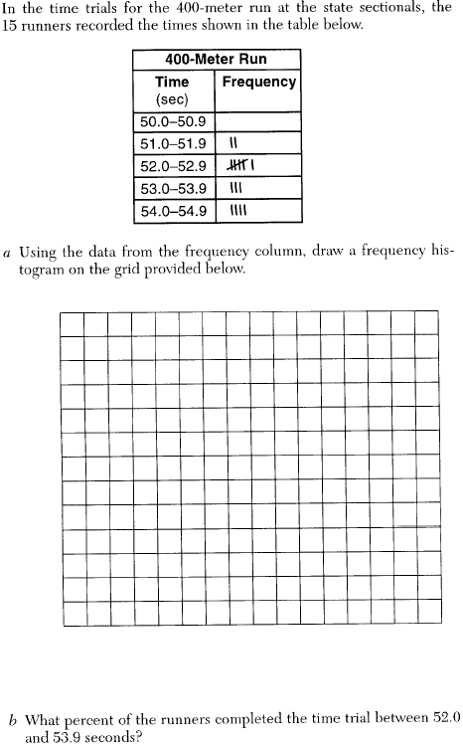

|  |
| --- |
| Sarah’s mathematics grades for one marking period were 85, 72, 97, 81, 77, 93, 100, 75, 86, 70, 96, and 80.   1. Complete the tally sheet and frequency table below, and construct and label a frequency histogram for Sarah’s grades using the accompanying grid. |